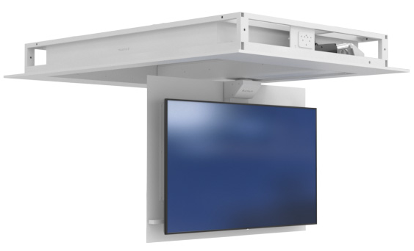
www.ultraliftaustralia.com.au | Ph: +61 3 9459 0873
sales@ultraliftaustralia.com.au | 82 Dougharty Road, Heidelberg West, VIC 3081 Australia

Spartan Swivel
Required Design Information

SWivel Direction
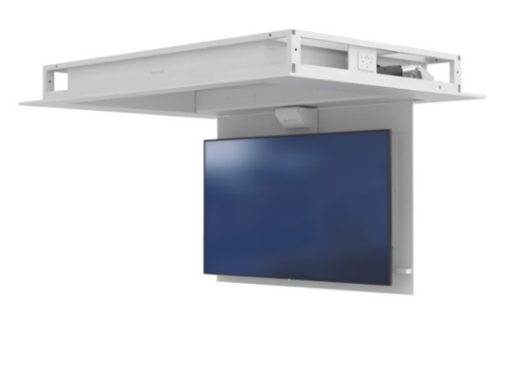
☐ Left to Right | ☐ Right to Left

Cavity Restrictions

Width: | Length: | Height:
Plaster thickness:

Colour

☐ Mannex Black ☐ Mannex White

COntrol

☐ Infra-Red (IR) ☐ Bluetooth ☐ Contact Closure ☐ RS232

TV (mounting responsibility of installer)

Make and Model Number:
* If TV has not been purchased yet, we will supply maximum screen sizing

NOTES:
- Please inform if you need another option for control (extra charges may apply).
- Custom panel finish available (extra charges apply)
- Custom options available to mount Sound bar brackets (extra charge, make and model number required).

